QUESTION 1

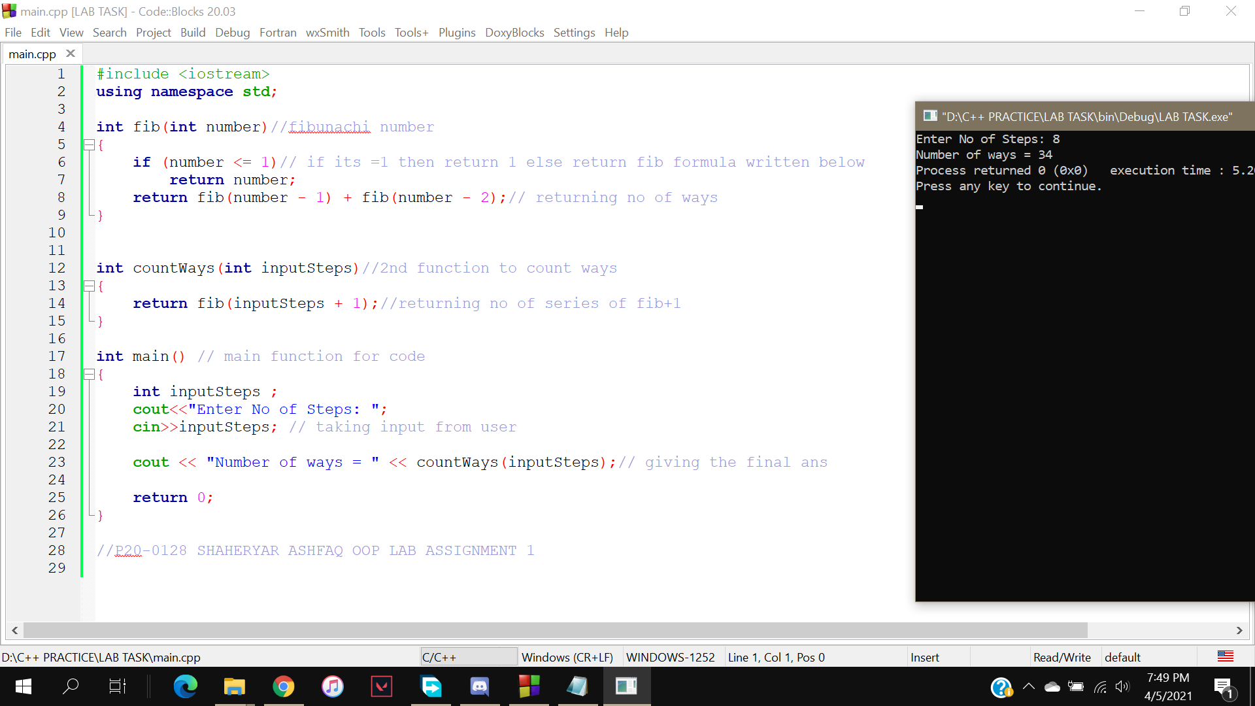

QUESTION 2

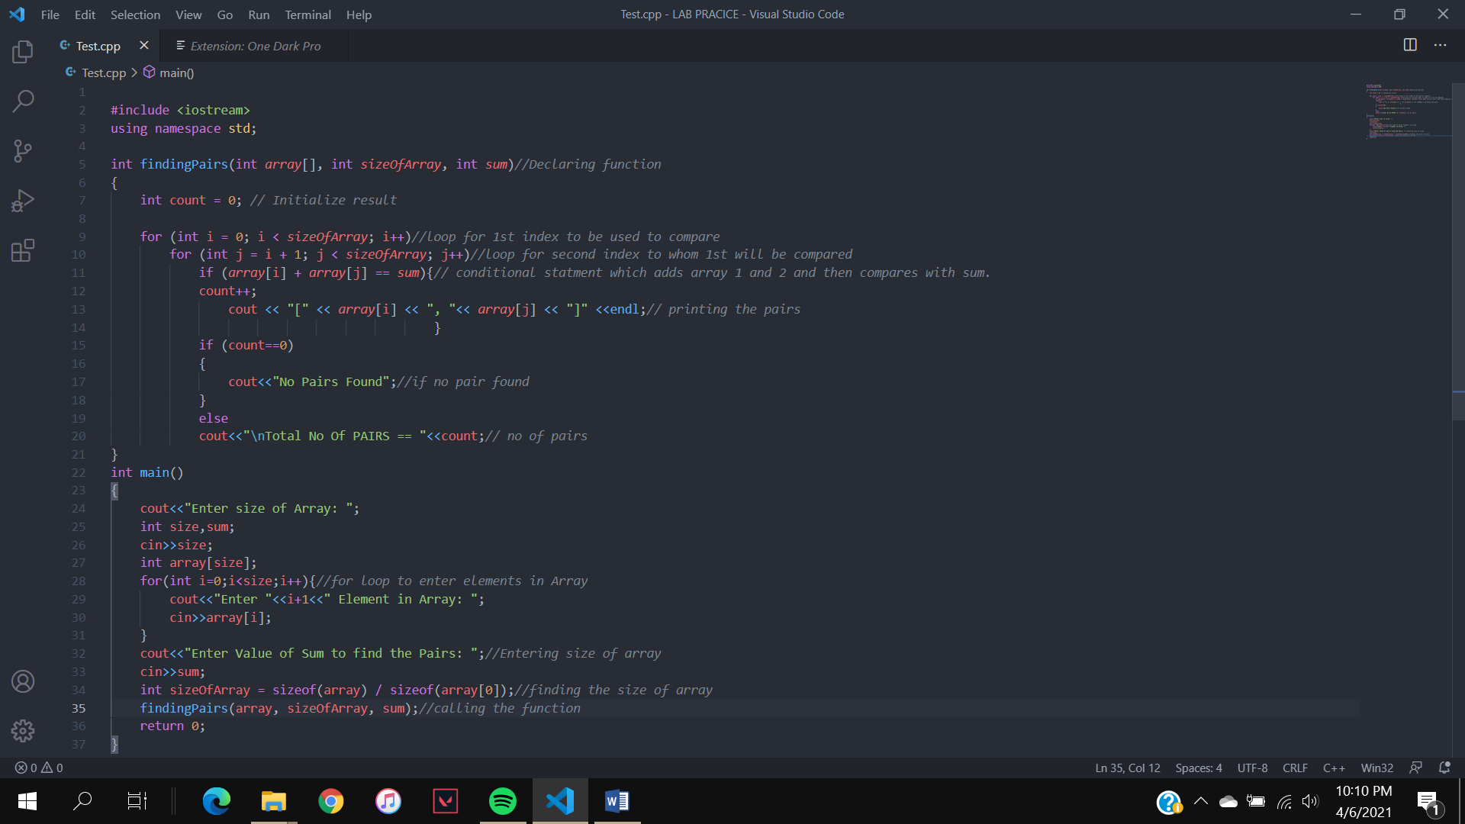

OUTPUT

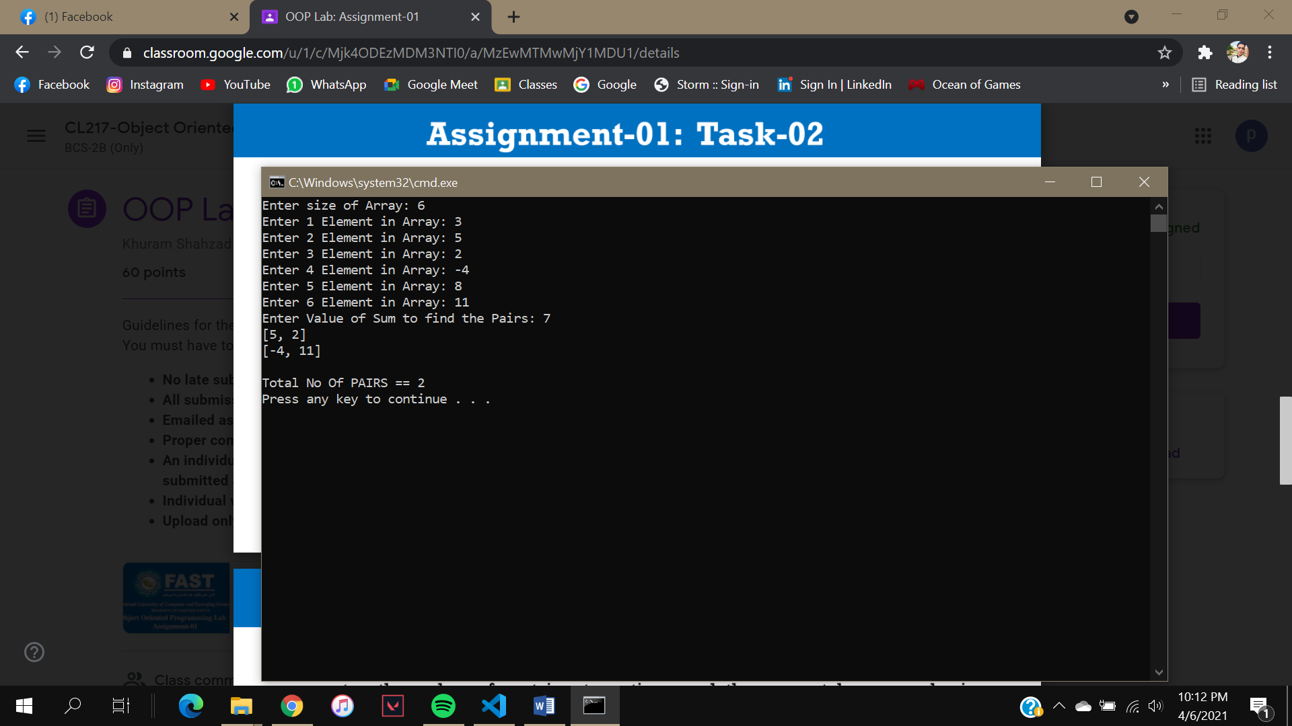

QUESTION 3

**INVERSE OF 2D MATRIX**

CODE:

#include<iostream>

using namespace std;

main()

{

int matrix[2][2];// initilzing array

int adjoint[2][2];// initilzing array

int row, column;

cout<<"2D Array Input:\n";

for(row=0;row<2;row++)//for loop for rows

{

for(column=0;column<2;column++)//for loop for columns

{

cout<<"\nmatrix["<<row<<"]["<<column<<"]= ";

cin>>matrix[row][column];//taking input from users

}

}

cout<<"\nThe 2-D Array is:\n";

for(row=0;row<2;row++)//for loop for rows

{

for(column=0;column<2;column++)//for loop for columns

{

cout<<"\t"<<matrix[row][column];//printing rows and colums

}

cout<<endl;

}

float determinent;

for(int row = 0; row < 2; row++)

determinent = (matrix[0][0] * matrix[1][1] - matrix[1][0] * matrix[0][1]);//finding determinent of Matrix

cout<<"\n\ndeterminant: "<<determinent;

if (determinent!=0) //Inverse is possible or not

cout <<"\n\nInverse is possible";

else

cout<<"Inverse is not possible";

//Swapping 1st and 4th element

adjoint[0][0]=matrix[0][0];

adjoint[1][1]=matrix[1][1];

matrix[0][0]=adjoint[1][1];

matrix[1][1]=adjoint[0][0];

//changing sings for 3rd and 2nd element

matrix[0][1]= -matrix[0][1];

matrix[1][0]= -matrix[1][0];

cout<<"\nAdjoint of the matrix is: \n\n" ; //finding adjoint of matrix

cout<<matrix[0][0] <<" "<<matrix[0][1]<<"\n"<<matrix[1][0]<<" "<<matrix[1][1]<<endl<<endl;

cout<<"Inverse of Matrix is equal to: \n\n\n";

cout<<matrix[0][0] <<" "<<matrix[0][1]<<"\n"<<matrix[1][0]<<" "<<matrix[1][1]<<endl;

cout<<"-----"<<endl;

cout<<determinent<<"\n\n\n"<<endl;

cout<<"Inverse of 2x2 Matrix is: \n"; //inverse of matrix

cout<<matrix[0][0]/determinent <<"\t"<<matrix[0][1]/determinent<<"\n"<<matrix[1][0]/determinent<<"\t"<<matrix[1][1]/determinent<<endl;

return 0;

}

OUTPUT

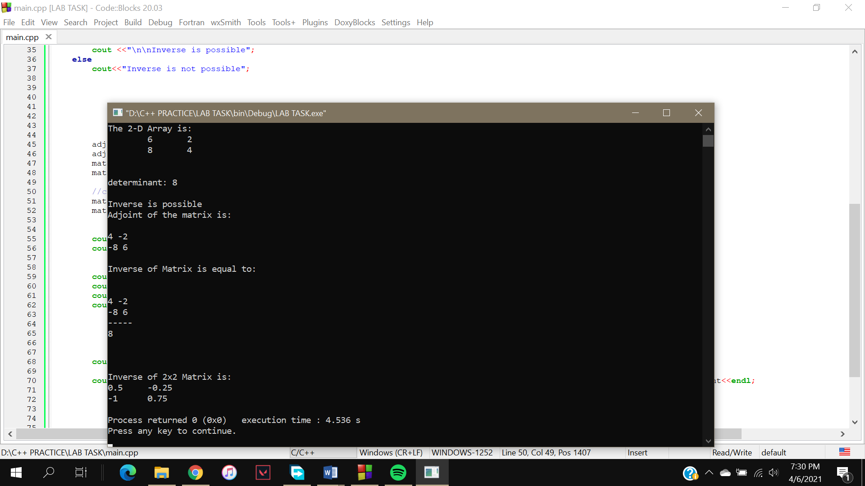

QUESTION 4

CODE

#include<iostream>

using namespace std;

struct userData{//declareing a custom data type with name of userData

string firstName;

string lastName;

int age;

int id;

string food;

string sport;

float gpa;

};

int main(){

userData u1,u2,u3,u4,u5,u6,u7; // initilizing members of structure up to 7

u1.firstName="Shaheryar";

u1.lastName="Ashfaq";

u1.age=20;

u1.id=128;

u1.food="chicken";

u1.sport="cricket";

u1.gpa=3.88;

u2.firstName="Taimoor";

u2.lastName="Hassan";

u2.age=18;

u2.id=602;

u2.food="bryani";

u2.sport="football";

u2.gpa=3.08;

u3.firstName="Armaghan";

u3.lastName="Ahmad";

u3.age=17;

u3.id=190;

u3.food="fish";

u3.sport="hockey";

u3.gpa=2.88;

u4.firstName="Changez";

u4.lastName="Khan";

u4.age=19;

u4.id=1;

u4.food="egg";

u4.sport="icehockey";

u4.gpa=3.18;

u5.firstName="Mahrukh";

u5.lastName="Habib";

u5.age=21;

u5.id=122;

u5.food="beef";

u5.sport="cooking";

u5.gpa=3.58;

u6.firstName="Alia";

u6.lastName="Asif";

u6.age=24;

u6.id=324;

u6.food="mutton";

u6.sport="carrom";

u6.gpa=3.22;

u7.firstName="Shiekh";

u7.lastName="Aslam";

u7.age=25;

u7.id=328;

u7.food="kebab";

u7.sport="baseball";

u7.gpa=1.88;

string input;

do{//using do while loop to get it executed

cout<<"\nEnter any detail (First||Last Name , Age, GPA, ID) to find record : ";//displaying messgae for user

cin>>input;

if(input=="Shaheryar"||input=="Ashfaq"||input=="20"||input=="3.88"||input=="128"||input=="chicken"||input=="cricket")

cout<<"\n\nFirst Name: "<<u1.firstName

<<"\nLast Name: "<<u1.lastName

<<"\nAge: "<<u1.age

<<"\nID: "<<u1.id

<<"\nFood: "<<u1.food

<<"\nSport: "<<u1.sport

<<"\nGPA: "<<u1.gpa

<<"\n\nFind Another Record or Type Exit to Quit\n";

else if(input=="Taimoor"||input=="Hassan"||input=="18"||input=="3.08"||input=="602"||input=="bryani"||input=="football")

cout<<"\n\nFirst Name: "<<u2.firstName

<<"\nLast Name: "<<u2.lastName

<<"\nAge: "<<u2.age

<<"\nID: "<<u2.id

<<"\nFood: "<<u2.food

<<"\nSport: "<<u2.sport

<<"\nGPA: "<<u2.gpa

<<"\n\nFind Another Record or Type Exit to Quit\n";

else if(input=="Armaghan"||input=="Ahmad"||input=="17"||input=="2.88"||input=="190"||input=="fish"||input=="hockey")

cout<<"\n\nFirst Name: "<<u3.firstName

<<"\nLast Name: "<<u3.lastName

<<"\nAge: "<<u3.age

<<"\nID: "<<u3.id

<<"\nFood: "<<u3.food

<<"\nSport: "<<u3.sport

<<"\nGPA: "<<u3.gpa

<<"\n\nFind Another Record or Type Exit to Quit\n";

else if(input=="Changez"||input=="Khan"||input=="19"||input=="3.18"||input=="1"||input=="egg"||input=="icehockey")

cout<<"\n\nFirst Name: "<<u4.firstName

<<"\nLast Name: "<<u4.lastName

<<"\nAge: "<<u4.age

<<"\nID: "<<u4.id

<<"\nFood: "<<u4.food

<<"\nSport: "<<u4.sport

<<"\nGPA: "<<u4.gpa

<<"\n\nFind Another Record or Type Exit to Quit\n";

else if(input=="Marukh"||input=="Habib"||input=="21"||input=="3.58"||input=="122"||input=="beef"||input=="cooking")

cout<<"\n\nFirst Name: "<<u5.firstName

<<"\nLast Name: "<<u5.lastName

<<"\nAge: "<<u5.age

<<"\nID: "<<u5.id

<<"\nFood: "<<u5.food

<<"\nSport: "<<u5.sport

<<"\nGPA: "<<u5.gpa

<<"\n\nFind Another Record or Type Exit to Quit\n";

else if(input=="Alia"||input=="Asif"||input=="24"||input=="3.22"||input=="324"||input=="mutton"||input=="carrom")

cout<<"\n\nFirst Name: "<<u6.firstName

<<"\nLast Name: "<<u6.lastName

<<"\nAge: "<<u6.age

<<"\nID: "<<u6.id

<<"\nFood: "<<u6.food

<<"\nSport: "<<u6.sport

<<"\nGPA: "<<u6.gpa

<<"\n\nFind Another Record or Type Exit to Quit\n";

else if(input=="Shiekh"||input=="Aslam"||input=="25"||input=="1.88"||input=="328"||input=="kebab"||input=="baseball")

cout<<"\n\nFirst Name: "<<u7.firstName

<<"\nLast Name: "<<u7.lastName

<<"\nAge: "<<u7.age

<<"\nID: "<<u7.id

<<"\nFood: "<<u7.food

<<"\nSport: "<<u7.sport

<<"\nGPA: "<<u7.gpa

<<"\n\nFind Another Record or Type Exit to Quit\n";

else if(input=="exit")

break;

else

cout<<"\nRECORD NOT FOUND\n\nTry Again or type Exit to Quit\n";

}

while(input!="exit");

return 0;

}

**OUTPUT**

